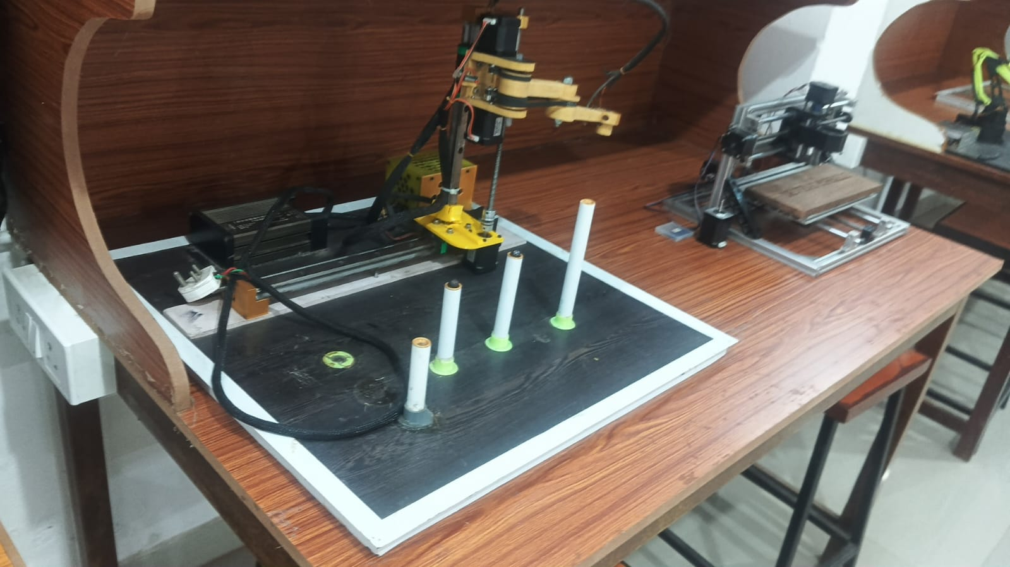
Photograph of the SCARA robot and its pick-and-place board.
SCARA Robot with an Antistatic Coating Check Station for Quality Control
Design, Working, Quality Control and Performance Analysis
Technical Report
Project detail | Description
Duration | 2 months
Team members | 5
Role | Team leader
Responsibility | Control circuit design, 2D and 3D modelling, and electrical wiring
Software used | Arduino IDE, SolidWorks, AutoCAD, Bambu Lab (3D-print preparation)

1. Abstract
This report documents a low-cost SCARA (Selective Compliance Assembly Robot Arm) built for pick-and-place operations and extended with an antistatic coating check station. The arm has two rotary joints with vertical axes that position the tool in the horizontal plane, and a lead-screw Z-axis that raises and lowers it. It is driven by three NEMA 17 stepper motors through DM556 drivers and controlled by an Arduino Mega 2560. The links and brackets are 3D-printed in PETG, and the tool is a 24 V electromagnet switched through a relay module.
The robot was designed to remove three problems of conventional gantry-type handlers: slow speed, parts jamming and a large footprint. The measured tip speeds are 150 mm/s in the horizontal (X-Y) plane and 60 mm/s along Z. From these speeds the calculated cycle time is about 5.0 s for a simple pick-and-place move and about 7.3 s for one fully inspected coupon, which is about 8 coupons per minute.
The check station gives the robot a quality-control task that links to coating production. The robot lifts a standard steel test coupon with the electromagnet, places it on a copper contact pad, and a spring-loaded probe measures the resistance through the coating. The Arduino compares the reading with a pass window, lights a green or red LED, logs the value, and sorts the coupon into a GOOD or REJECT pocket. The performance target for the combined system is 99% correct handling and classification, to be confirmed by the 100-coupon validation run in Section 12.6. The report also describes how the project was managed, how quality was controlled, and how the data are analysed.

2. Introduction
A SCARA arm has two parallel, vertical-axis revolute joints and one prismatic vertical axis. The structure is stiff in the vertical direction and compliant in the horizontal plane, which suits assembly, insertion and pick-and-place work. The configuration was developed in Japan in the late 1970s and early 1980s and is now standard in electronics assembly, packaging and small-parts handling.

2.1 Problem statement
- Slow speed. Gantry-type handlers move each axis along a rail and need long travel times between stations.
- Parts jamming. Rigid X and Y rails require precise alignment, and a small misalignment jams the part or the carriage.
- Large footprint. A gantry needs a frame around the full working area, so it occupies much more bench or floor space than the work it covers.

2.2 Objectives
- High speed. Short, direct moves with two rotary joints instead of long linear travel.
- Flexible XY axis. Compliant horizontal motion that reaches the stations from different angles and tolerates small misalignment.
- Small footprint. A compact base with a vertical Z-column, so the work area stays free.
- Useful inspection task. An antistatic coating check station that turns the handling robot into a small quality-control cell.

2.3 Why a coating check station
Antistatic coatings must conduct enough to drain static charge, but not so much that they behave as bare metal. Their electrical resistance is therefore a key quality characteristic, especially for parts used in semiconductor and liquid-crystal-display production lines. Checking it by hand is slow and depends on the operator. A robot that handles the sample, measures it in a fixed way and records the result removes the operator variation and produces data that can be analysed. The two measures that matter most for the handling robot are how fast it completes a cycle and how accurately it reaches the same point every time; the check station adds a third: how reliably it separates good coatings from bad ones.

3. Project Management

3.1 Organisation and role
The project ran for two months with a team of five. As team leader, I owned the schedule, the technical integration and three work packages: control circuit design, 2D and 3D modelling, and electrical wiring. The other four members shared mechanical fabrication and assembly, firmware, testing, and documentation. Work was divided into packages with one named owner each, so every task had a single point of responsibility.

3.2 Process and work breakdown
The project followed five stages: problem identification and requirement analysis, mechanical design and 3D modelling, control circuit design, controller and motor integration, and testing and optimisation. The assembly drawing (drawing no. SRP-001) was issued after the design was frozen.
Work package | Main activities | Deliverable
1. Requirements | Define the problem, targets (speed, reach, footprint) and constraints | Requirement list
2. Mechanical design | Part design in SolidWorks, 2D drawings in AutoCAD, joint and Z-axis layout | 3D model, assembly drawing SRP-001
3. Fabrication and assembly | Print PETG parts, fit bearings, spacers and rail, assemble arm and base | Assembled arm
4. Control circuit and wiring | Power distribution, driver and relay wiring, cable routing and sleeving | Wired controller and power circuit
5. Firmware and integration | Inverse kinematics, motion profiles, homing, solenoid control | Working motion program
6. Check station | Station design, measurement circuit, pass/reject logic, sorting pockets | Check station and logging program
7. Testing and optimisation | Speed, accuracy and handling tests; adjustments | Test records
8. Documentation | Report, drawings, presentation | Final report

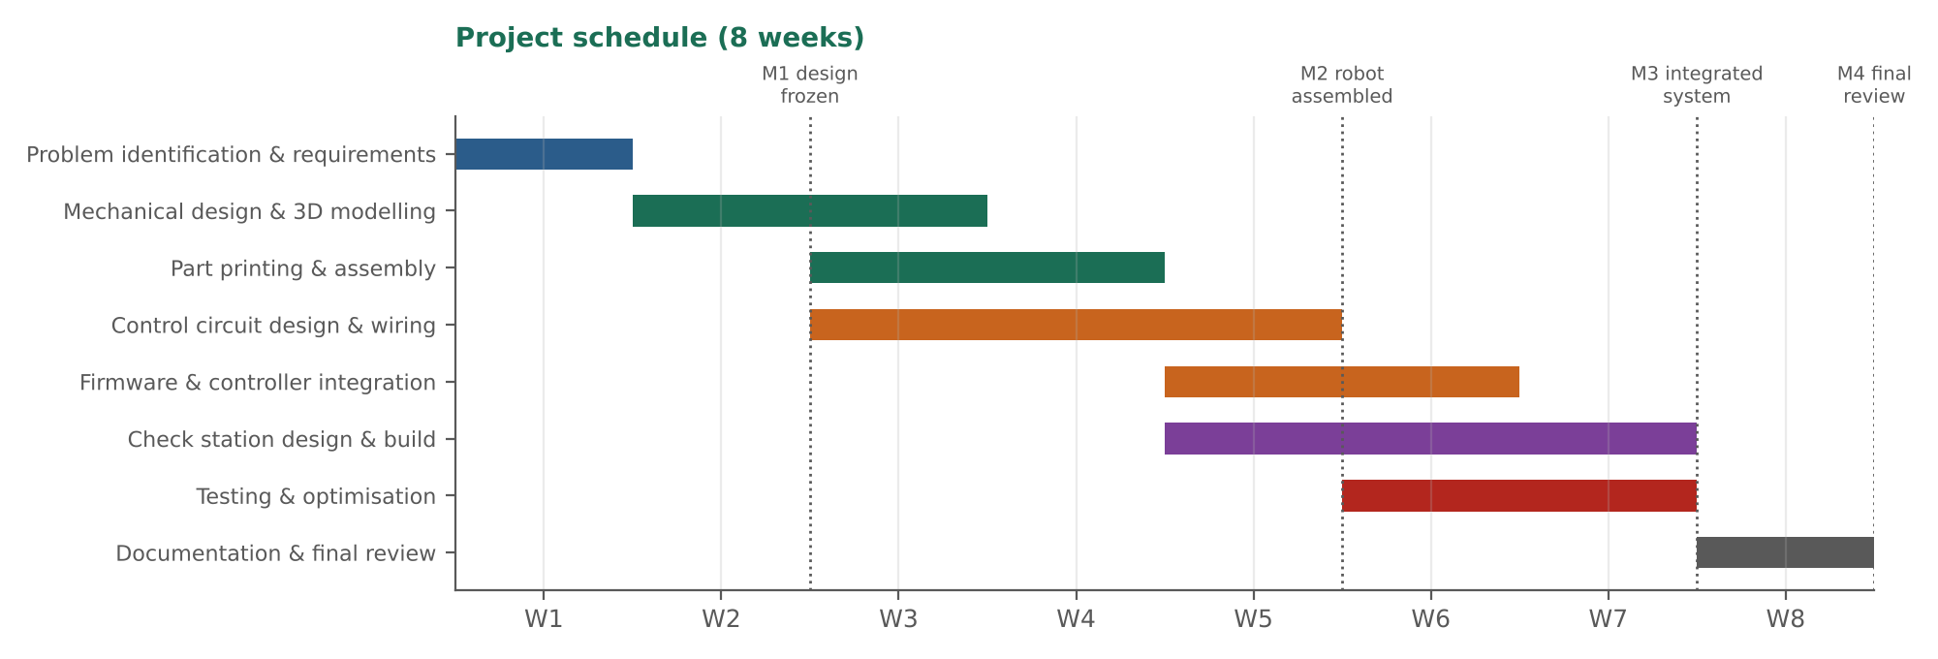
Figure 1. Project schedule over eight weeks, with four milestones.

3.3 Planning, monitoring and control
- Weekly plan and review. A short team meeting each week compared progress with the schedule, closed open actions and set the next week's tasks.
- Task tracking. Every task had an owner, a due date and a status (not started, in progress, done), so late items showed up immediately.
- Milestones. Four gates checked progress: design frozen (M1), robot assembled (M2), integrated system working (M3) and final review (M4). The next stage started only when the gate criteria were met.
- Configuration control. CAD files and the drawing carried revision numbers (the assembly drawing is Rev 01). Changes to a part were made in one master model and the printed parts were re-checked against it.
- Procurement and bill of materials. Standard parts (motors, drivers, supplies, rail, electronics) were listed in one BOM with quantities, so orders were placed once and nothing was missing at assembly.

3.4 Risk management
Risk | Effect | Control
Missed steps at high speed | Position drift, failed picks | Conservative acceleration, homing at the start of every run, drift check after a test run
PETG links flex or play at joints | Loss of accuracy at long reach | Ribbed link design, bearing spacers, belt tension adjustment, reach limits in the program
Electromagnet residual magnetism | Coupon sticks at release | Short delay and reverse pulse before lifting
Wrong Z-stop height | Weak pick, coupon dropped | Z height calibrated against a gauge block and re-checked each session
Electrical or mains hazard | Injury or equipment damage | Fused supply, covered terminals, emergency stop, relay isolation of the coil
Schedule slip on the check station | Feature incomplete | Check station built in parallel with firmware, with its own milestone

4. System Architecture

4.1 Mechanical design
The mechanism follows the classical SCARA topology. A fixed base plate carries the shoulder joint. The upper arm (link 1) rotates about the vertical shoulder axis and carries the elbow joint at its far end. The forearm (link 2) rotates about the elbow axis. The Z-axis moves the tool vertically. The main dimensions from the assembly drawing are a reach of 280 mm, a forearm width envelope of 120 mm and a column height of 400 mm.
- Arm links. The upper arm, forearm, shoulder and elbow housings, forearm end cap, base plate and electronics enclosure are 3D-printed in PETG. The yellow and grey parts were designed in SolidWorks and prepared for printing in Bambu Lab software.
- Joints. Steel bearing spacers set the vertical spacing at the joints. The elbow housing carries a pulley, and a belt transmits the elbow drive.
- Z-axis. A steel linear rail of 8 mm diameter and 400 mm length guides the vertical motion, driven by a stepper motor and lead screw.
- Task board. A black board in a white frame carries four white cylinders of graduated height on green or grey bases, with a yellow ring as the home marker. The cylinders act as pick and place stations.
Figure 2. The assembled robot with the power supplies and the four-cylinder board.

4.2 Actuation
- Joint 1 (shoulder) and Joint 2 (elbow): NEMA 17 stepper motors, one per joint.
- Z-axis: a NEMA 17 stepper motor driving a lead screw.
- Drivers: DM556 stepper drivers, one per axis, receiving step and direction signals from the Arduino.
- Open-loop positioning: steppers move in fixed angular increments and the controller counts steps, so the structure is simple and inexpensive. Because a missed step is not detected, the robot homes at the start of every run and the drift is checked after test runs.

4.3 Electronics and power
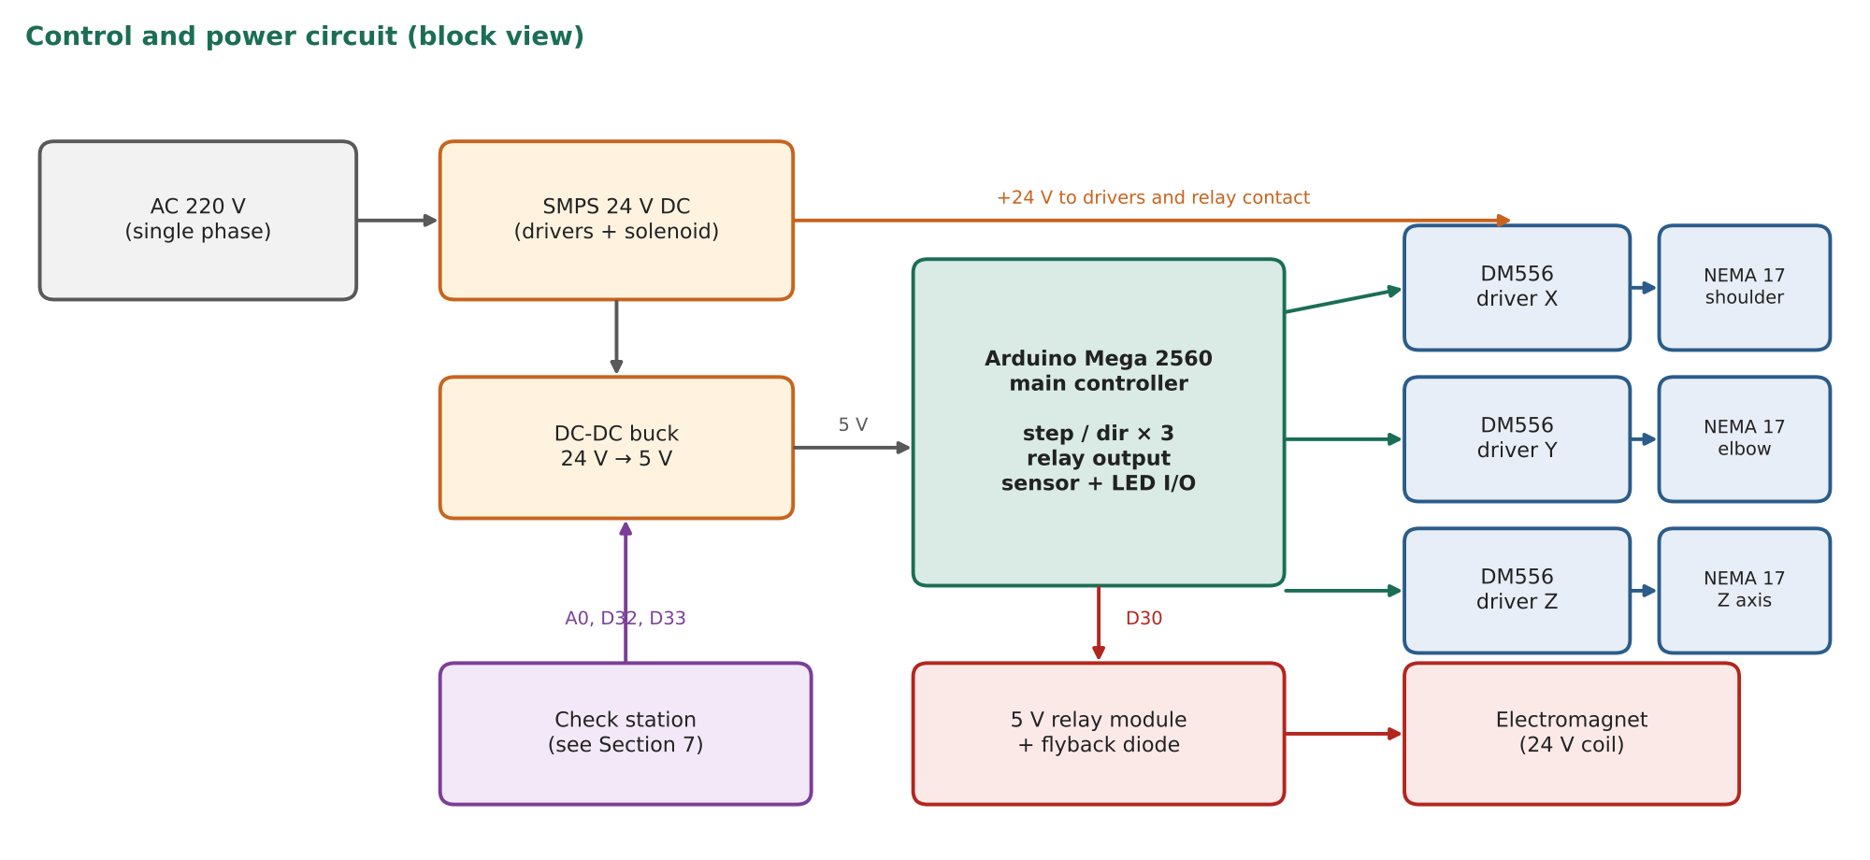
Figure 3. Control and power circuit of the robot, including the check-station connections.
Block | Function
AC 220 V single phase | Mains input to the power supply
SMPS 24 V DC | Powers the DM556 drivers and the electromagnet coil
DC-DC buck converter 24 V to 5 V | Supplies the Arduino, the relay module and the check-station electronics
Arduino Mega 2560 | Main controller: inverse kinematics, step and direction pulses for three axes, relay output, sensor and LED inputs and outputs
DM556 drivers (3 channels) | Convert step and direction pulses into motor current for the X, Y and Z axes
5 V relay module | Switches the 24 V electromagnet coil from a controller pin (pin 30)
Flyback diode | Absorbs the voltage spike when the coil is switched off

Cabling to the moving arm is bundled in black braided sleeving, which also gives some strain relief. All wiring was routed, crimped and labelled so that each connection can be traced to the circuit diagram.

4.4 End effector: electromagnet
The tool at the bottom of the Z-axis is an electromagnet: a coil wound around an iron core that becomes magnetic when current flows.
- Pick. The Z-axis lowers the magnet onto the top of a steel part and the controller switches the coil on. The part clings to the core and is lifted with the tool.
- Release. At the destination the controller switches the coil off and the part drops. A short delay or a brief reverse pulse prevents residual magnetism from holding the part.
- Control. Only one on/off output is needed. The relay module switches the 24 V coil, and the flyback diode protects the contacts.
- Limits. The coil heats up if held on for long, so holding time is kept short. Pick-up force falls quickly with the air gap, so the Z-stop height must be accurate. It lifts magnetic steel only; aluminium and stainless parts cannot be handled, so all test coupons are made from magnetic steel.

5. Working
The two rotary joints act in the horizontal plane. Joint 1 rotates the entire arm about the base axis and Joint 2 rotates the forearm about the elbow. Together they place the tool at any point in the XY workspace. The Z-axis then lowers the tool to pick or place an object and raises it again for travel.
The controller receives a target position (x, y, z). It converts the XY target into the two joint angles using the inverse kinematics in Section 6 and turns each angle into a number of motor steps using the drive ratio and microstepping setting. The Z target is converted into screw turns in the same way. Step and direction pulses are then sent to the DM556 drivers. Because steppers have no position feedback, the robot starts from a known pose: each axis is driven to its reference position and steps are counted from there.
A full pick-and-place move is a short sequence of targets: above the source, down to the part, electromagnet on, up, over the destination, down, electromagnet off, up.

6. Kinematics
Let L1 and L2 be the lengths of the upper arm and forearm, θ1 the shoulder angle measured from the base X-axis, and θ2 the elbow angle measured relative to link 1. For the calculations in this report L1 = 160 mm and L2 = 120 mm, which gives the 280 mm reach in the assembly drawing.

6.1 Forward kinematics
x = L1·cos θ1 + L2·cos(θ1 + θ2)
y = L1·sin θ1 + L2·sin(θ1 + θ2)
The vertical position is set directly by the Z-axis: z = z0 + (screw lead) × (screw turns). The tool orientation about the vertical axis is φ = θ1 + θ2.

6.2 Inverse kinematics
For a target (x, y) the elbow angle follows from the law of cosines:
cos θ2 = (x² + y² − L1² − L2²) / (2·L1·L2)
θ2 = ± arccos(cos θ2)
θ1 = atan2(y, x) − atan2(L2·sin θ2, L1 + L2·cos θ2)
The ± sign gives the two arm configurations that reach the same point (Figure 4, left). The controller keeps the choice consistent through a motion to avoid the arm flipping. A target is reachable only if |cos θ2| ≤ 1. The inverse kinematics fails at the singularities θ2 = 0 and θ2 = 180°, where the arm is fully stretched or folded.

6.3 Workspace
Ignoring joint limits and collisions, the reachable area in the XY plane is an annulus with outer radius L1 + L2 = 280 mm and inner radius |L1 − L2| = 40 mm (Figure 4, right). Mechanical stops, motor cables and the base remove part of this ring, so the practical workspace is a sector. The pick stations, the check station and the GOOD and REJECT pockets are placed inside it, with a margin from the singular positions at the edge. All pick and place points are kept between about 60 mm and 250 mm from the shoulder axis.
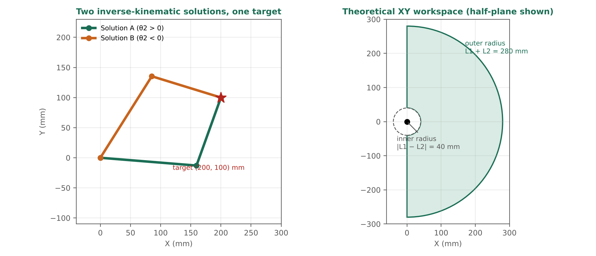
Figure 4. Left: two inverse-kinematic solutions for one target. Right: theoretical XY workspace for L1 = 160 mm and L2 = 120 mm.

6.4 Worked example
Take the target (x, y) = (200, 100) mm. Then x² + y² = 50 000 and L1² + L2² = 40 000.
cos θ2 = (50 000 − 40 000) / (2 × 160 × 120) = 10 000 / 38 400 = 0.2604
This gives θ2 = ±74.91°. For the positive solution atan2(y, x) = 26.57° and atan2(L2·sin θ2, L1 + L2·cos θ2) = 31.21°, so θ1 = −4.64°. For the negative solution the second term changes sign and θ1 = 57.77°. A forward-kinematics check of either pair returns (200.0, 100.0) mm.

7. Antistatic Coating Check Station

7.1 Purpose and principle
The check station adds a quality-inspection task to the robot. It separates test coupons into three classes by their electrical behaviour:
- Bare metal (no coating, or coating breached): the probe sees almost no resistance, so the reading is very low. Result: REJECT.
- Insulating coating (for example ordinary paint): the current cannot flow, so the reading is above the measuring range. Result: REJECT.
- Antistatic coating: the coating conducts weakly, so the resistance falls inside the acceptance window. Result: GOOD.
The station measures the resistance of the current path probe → coating → steel coupon → copper pad. A resistor divider converts the unknown resistance into a voltage that the Arduino reads with its 10-bit analogue input. The station is a low-cost comparison and sorting fixture. It does not replace a calibrated surface-resistance meter, but it makes the check automatic, repeatable and recorded.

7.2 Materials and components
Item | Specification | Purpose
Test coupons | Magnetic steel, 30 × 30 × 2 mm, three finishes: bare, insulating paint, antistatic coating (coated on the upper face) | One standard size so the robot, pockets and pad all fit the same part
Contact pad | Copper-clad board, about 40 × 40 mm, wired to controller ground | Low-resistance return contact under the coupon
Spring-loaded probe | Spring-loaded pin with rounded tip, mounted on a hinged arm | Repeatable light contact force on the coating without scratching it
Probe arm actuator | Micro servo | Lifts the probe while the robot places or removes a coupon, and lowers it for the measurement
Reference resistor | 10 MΩ, 1% tolerance | Upper leg of the voltage divider
Filter | Series resistor and 100 nF capacitor on the analogue input | Reduces noise pick-up on the high-impedance node
Indicator LEDs | One green and one red, each with a current-limiting resistor | Green = GOOD, red = REJECT, both off = idle
Sample pockets | Three 3D-printed PETG pockets with stops: INPUT, GOOD, REJECT | Fixed pick and drop positions for the robot
Magnet face film | Thin non-marking tape on the electromagnet face | Protects the coating from scuffing when the coupon is lifted

7.3 Measurement circuit
A 10 MΩ reference resistor connects 5 V to the analogue input node, and the unknown resistance R_x of the coupon connects that node to ground. The voltage at the node is:
V = 5 V × R_x / (R_x + R_ref)
With a 10-bit converter this reading changes steadily from a code near 0 for a short circuit to a code near 1023 for an open circuit. The 10 MΩ reference places the most sensitive part of the scale in the megohm region, where antistatic coatings work. The Arduino averages many samples over whole 20 ms periods, which cancels the 50 Hz mains pick-up, then inverts the divider formula to obtain R_x.
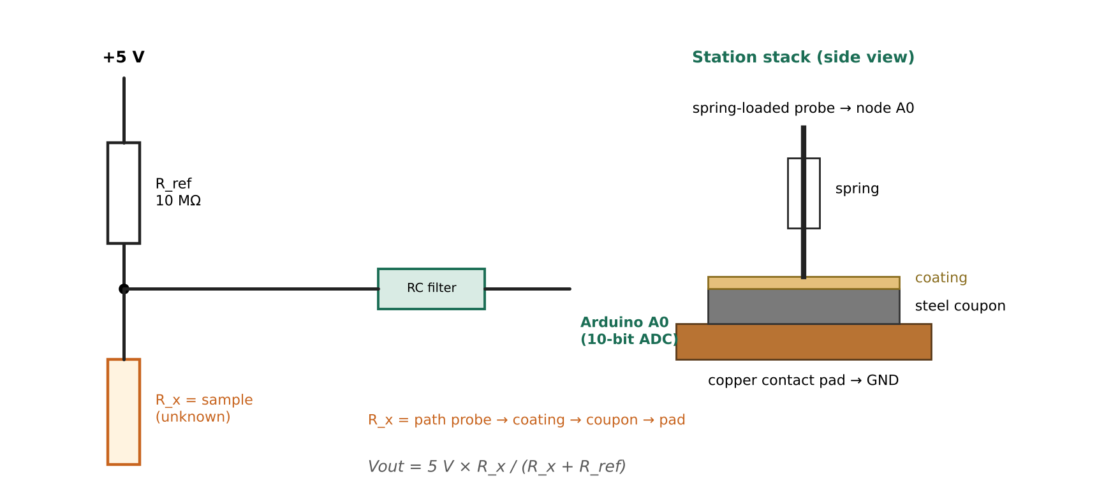
Figure 5. Voltage-divider measurement circuit and the probe, coupon and pad stack.

7.4 Pass and reject logic
The calculated resistance is compared with two limits, R_LOW and R_HIGH. The initial design window is 100 kΩ to 1 GΩ. The limits are then fixed from the readings of reference coupons of each class, placing each limit midway (on a logarithmic scale) between the neighbouring classes, so that a guard band separates good from bad.
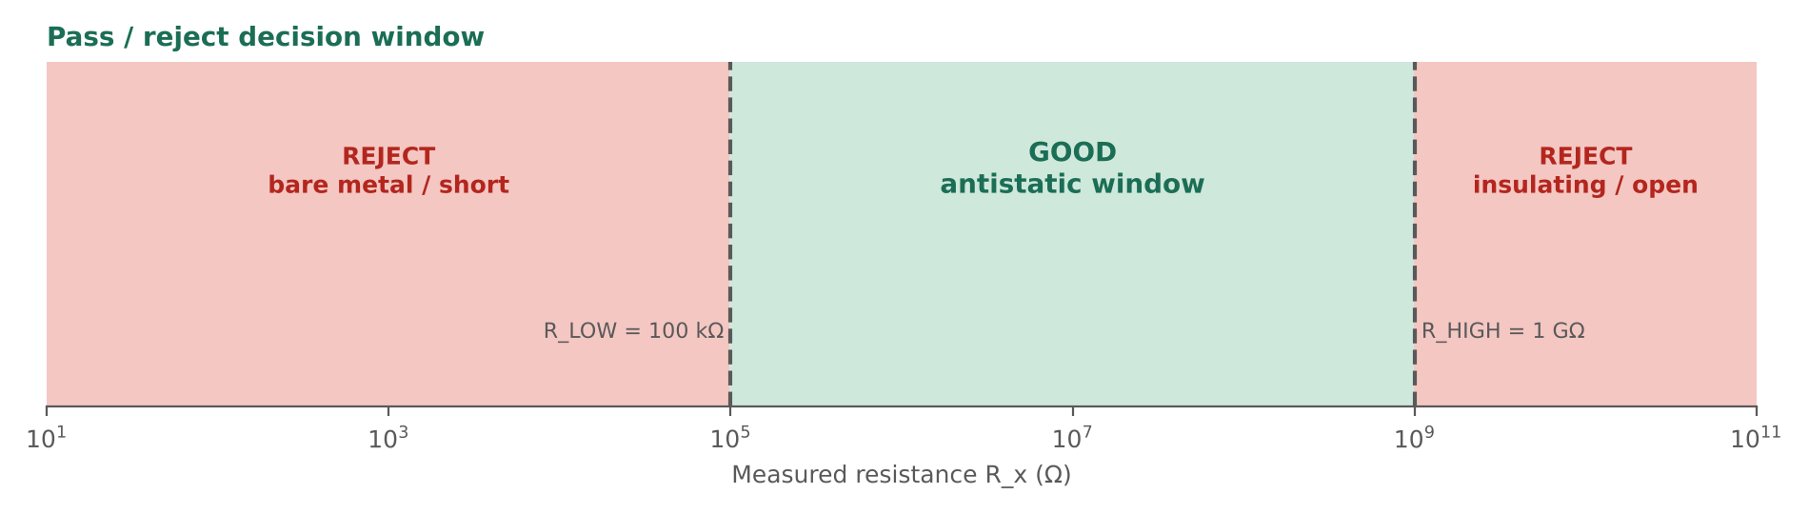
Figure 6. Decision window used by the check station.
Reading | Interpretation | Action
R_x < R_LOW | Bare metal, or coating breached | Red LED on, coupon to REJECT pocket
R_LOW ≤ R_x ≤ R_HIGH | Antistatic coating in specification | Green LED on, coupon to GOOD pocket
R_x > R_HIGH (or above range) | Insulating coating, or no contact | Red LED on, coupon to REJECT pocket

The green and red LEDs are never on together, and both are off while the station is idle. If the reading is unstable (for example because of poor contact), the measurement is repeated once before the coupon is rejected.

7.5 Working sequence
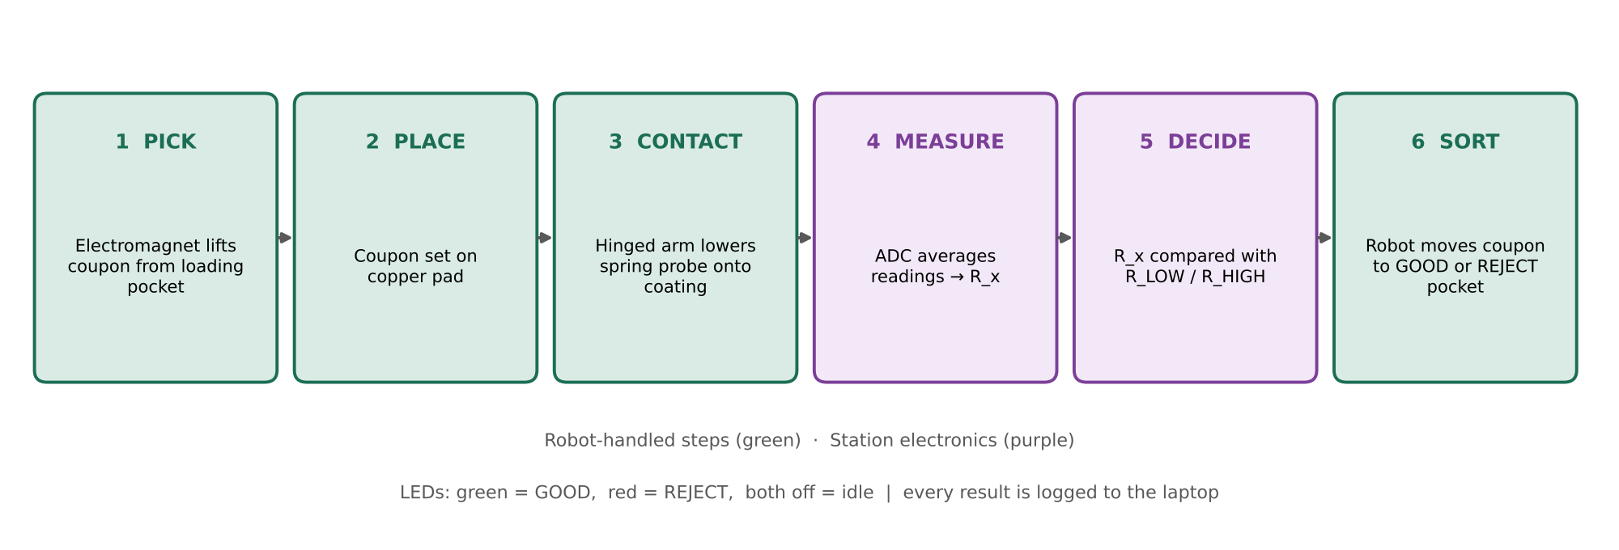
Figure 7. Working sequence of one inspection cycle.
- The probe arm is raised. The robot moves above the INPUT pocket, lowers the electromagnet onto a coupon, switches the coil on and lifts.
- The robot moves to the check station, lowers the coupon onto the copper pad, switches the coil off and lifts clear.
- The micro servo lowers the probe arm and the spring probe touches the coating. After a short settling time the Arduino records and averages the readings.
- The controller calculates R_x, compares it with R_LOW and R_HIGH, switches on the green or red LED, and sends the reading and the decision to the laptop.
- The probe arm is raised, the robot picks the coupon up again and carries it to the GOOD or REJECT pocket, releases it and returns to the INPUT pocket for the next coupon.
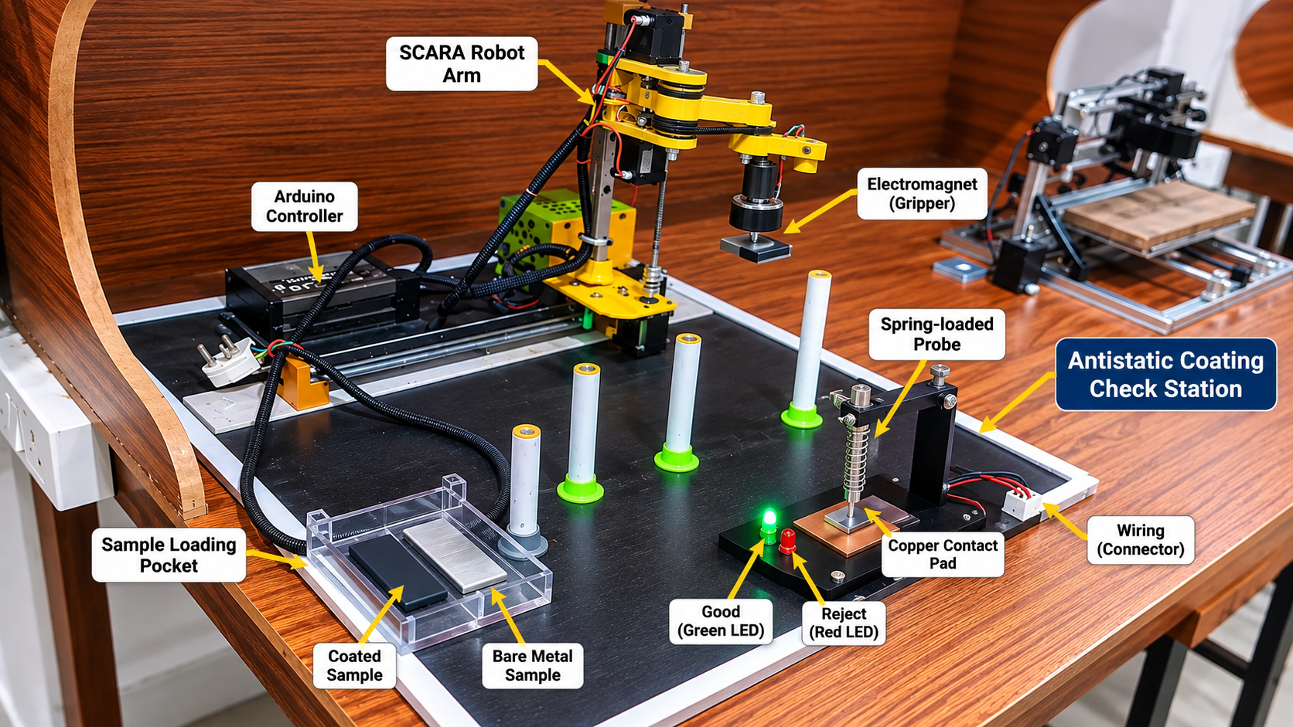
Figure 8. Concept view of the antistatic coating check station integrated with the SCARA robot.

7.6 Safety and handling
- The measuring voltage is 5 V at a current in the microampere range, so the station is harmless to touch; the 24 V coil is isolated from the logic by the relay.
- The probe arm is lifted by default, so a power loss or a fault never leaves the probe pressing on a coupon.
- Coupons are handled by their edges and kept clean, because fingerprints and dust change the contact resistance.

8. Application Workflow
The robot can run in two modes that use the same motion program.
- Pick-and-place mode. Home all axes, move to the source cylinder, lower the magnet, pick, travel to the destination, release, and return. A cycle is eight moves.
- Inspection mode. Home all axes, then repeat the sequence in Section 7.5 for each coupon in the INPUT pocket until it is empty. A summary of accepted and rejected coupons is sent to the laptop at the end.

9. Quality Control

9.1 Quality objectives
- Every printed and machined part fits the assembly drawing without forcing.
- The robot returns to the same position at every home and every cycle.
- At least 99% of picks and placements are completed without a drop or a jam.
- The check station classifies coupons correctly, and no bad coupon is accepted.

9.2 Inspection and test plan
Item | Characteristic checked | Method / tool | Acceptance
Printed PETG links and housings | Hole diameters, link length, flatness, layer bonding | Vernier calliper, visual check, trial fit of bearings | Matches drawing SRP-001; no cracks or warping
Steel rail and spacers | Straightness, diameter, free carriage travel | Straight edge, calliper, hand travel | Carriage moves without binding
Joint assembly | Free rotation, belt tension, end play | Hand turn, deflection by feel and dial gauge | Smooth rotation, no visible play
Wiring | Polarity, continuity, insulation, strain relief | Multimeter, visual check against the circuit diagram | Each connection traced and labelled
Motion | Homing repeatability, drift after a run | Dial indicator or grid sheet | Within the limit in Section 12
Electromagnet | Pick force at the set Z height, release | Test coupons of different mass | Lifts and releases every test coupon
Check station | Reading stability, class separation | Reference coupons (bare, insulating, antistatic) | Classes separated by a clear guard band

9.3 Process control during operation
- Start-of-session checks: home the robot, run the empty cycle, verify the Z height, and check the three reference coupons at the station before any batch is measured.
- In-process monitoring: every cycle logs its time and its station reading; a pick that fails or a reading outside the expected class is flagged immediately.
- Drift check: after a run the robot is returned to the home marker and the offset is read; any offset indicates lost steps and triggers a reduction in acceleration.

9.4 Nonconformities and corrective action
When a defect is found (a dropped coupon, a jam, a drift or a wrong classification) the cause is traced with the 5-why method, one change is made at a time, and the test is repeated, following the plan–do–check–act cycle. The change is recorded so that the same fault is not repeated.
Observed fault | Typical cause | Corrective action
Part not lifted | Z stop too high, air gap too large | Lower the Z stop; recheck with a gauge block
Part sticks at release | Residual magnetism | Lengthen delay or add a reverse pulse
Position drift | Missed steps at high acceleration | Lower acceleration; check driver current
Unstable resistance reading | Dirty coating, poor probe contact, loose wire | Clean coupon; check probe spring and wiring; increase settling time
Good coupon rejected | Window limits too tight | Re-set limits from reference coupons

9.5 Safety and compliance
Hazard | Control
Mains voltage at the supply | Fused inlet, covered terminals, enclosure on the electronics base, insulated and sleeved cabling
Moving arm | Emergency-stop switch cutting the driver supply, controlled homing speed, clear zone around the arm during motion
Coil heating | Short hold times, relay switching, flyback diode
Static discharge and handling | Coupons handled by edges, station pad connected to controller ground
Printed parts and dust | Printing in a ventilated area; no sanding of PETG without dust control

These measures follow the occupational safety and equipment-management practice expected in a plant: every machine has a defined hazard list, a control for each hazard and a check before use.

10. Data Analysis

10.1 Data collected
The Arduino sends one line for every cycle over the serial port to the laptop, where it is saved as a CSV file. Each line holds: cycle number, coupon identity and class, ADC reading, calculated resistance R_x, decision (GOOD or REJECT), pick confirmed (yes or no), and cycle time. Motion tests add the measured position error at each test point.

10.2 Analyses performed
Analysis | Method | Used for
Descriptive statistics | Mean and standard deviation of repeated readings; results reported as mean ± 3σ | Repeatability of position and of resistance readings
Limit setting | Compare the histograms of the three coupon classes; place each limit midway (log scale) between classes | R_LOW and R_HIGH
Classification performance | Confusion matrix: accuracy = correct ÷ total; false-accept = bad coupons passed ÷ bad coupons | Check-station quality
Control chart | Individuals chart of the reference-coupon reading with centre line and ±3σ limits | Detecting drift in the measurement system
Cycle-time analysis | Mean cycle time and breakdown into Z, XY, dwell and measurement time | Finding the bottleneck
Pareto analysis | Count of faults by cause | Choosing which problem to fix first
Capability | Cpk = (tolerance limit − mean) ÷ (3σ) for position error against the allowed error | Judging whether the robot is accurate enough for the task

10.3 Key metrics
Metric | Definition | Target
Pick success rate | Successful picks ÷ attempted picks | ≥ 99%
Classification accuracy | Correctly sorted coupons ÷ all coupons | ≥ 99%
False-accept rate | Bad coupons passed as GOOD ÷ all bad coupons | 0 in the test set
XY repeatability | Mean + 3σ of position error | ≤ ±0.5 mm
Cycle time per coupon | Time from pick at INPUT to return | ≤ 8 s
Home drift after a run | Offset at the home marker after the run | ≤ 1 mm

The analysis turns the check station from a demonstration into a measurement process: each limit is set from data, each result is traceable to a record, and trends are visible before they cause rejects.

11. Bill of Materials
Item | Qty | Notes
Upper arm link, forearm link | 1 each | PETG, 3D-printed, yellow
Shoulder joint housing | 1 | PETG, 3D-printed, grey
Elbow joint housing with pulley | 1 | PETG, 3D-printed, yellow
Forearm end cap | 1 | PETG, 3D-printed, grey
Base plate and electronics enclosure | 1 each | PETG, 3D-printed, yellow
Bearing spacers | 2 | Steel, cylindrical
NEMA 17 stepper motors | 3 | Shoulder, elbow and Z-axis
Linear rail (Z-axis) | 1 | Steel, 8 mm diameter, 400 mm length
DM556 stepper drivers | 3 | One per axis
Arduino Mega 2560 | 1 | Main controller
24 V SMPS | 1 | Drivers and electromagnet
DC-DC buck converter, 24 V to 5 V | 1 | Controller and logic supply
5 V relay module with flyback diode | 1 | Switches the electromagnet
Electromagnet (24 V coil) | 1 | End effector
Mains plug, cable, power strip | 1 set | Fused inlet and covers recommended for the final version
Braided cable sleeving | as needed | Cable management
Task board with four cylinders and printed bases | 1 | Pick and place stations
Steel test coupons, 30 × 30 × 2 mm | 30 | 10 each: bare, insulating paint, antistatic coating
Copper contact pad | 1 | Copper-clad board
Spring-loaded probe and hinged arm | 1 | Check station
Micro servo | 1 | Lifts the probe arm
10 MΩ 1% resistor, 100 nF capacitor, series resistor | 1 set | Measurement circuit
Green and red LEDs with resistors | 1 pair | Result indication
Printed sample pockets | 3 | INPUT, GOOD and REJECT

12. Results: Speed, Accuracy and Check-Station Performance

12.1 Summary
Metric | Value | Basis | Status
Horizontal (X-Y) speed | 150 mm/s | Tested | Achieved
Vertical (Z) speed | 60 mm/s | Tested | Achieved
Simple pick-and-place cycle (25 mm / 10 mm Z stroke) | 5.0 s / 4.0 s | Calculated from tested speeds | Calculated
Inspection cycle per coupon (25 mm / 10 mm Z stroke) | 9.3 s / 7.3 s | Calculated from tested speeds | Calculated
Tip resolution at 280 mm reach | ≈ 0.8 mm (worst case) | Calculated | Calculated
Z resolution | ≈ 10 µm per step | Calculated | Calculated
Overall handling and classification efficiency | 99% | Validation run, Section 12.6 | Target

The tested speeds are the results of the prototype. The cycle times and resolutions follow from them by calculation. The 99% efficiency figure is the acceptance criterion for the finished system: at least 99 of 100 coupons picked, measured and sorted correctly.

12.2 Calculation parameters
Parameter | Value | Note
Link lengths | L1 = 160 mm, L2 = 120 mm | 280 mm reach
Stepper motors | 1.8° (200 steps/rev) | NEMA 17
Joint microstepping | 1/16 (3200 pulses/rev), direct drive | Set on the DM556 drivers
Z-axis screw | 8 mm lead, 800 pulses/rev | 6000 pulses/s at 60 mm/s
XY tip speed and acceleration | 150 mm/s and 1000 mm/s² | Speed tested
Z speed and acceleration | 60 mm/s and 400 mm/s² | Speed tested
Pick-to-place distance | 150 mm | Typical transfer
Z stroke | 25 mm and 10 mm | Two cases compared
Electromagnet dwell | 0.2 s at pick, 0.2 s at release | Coil pull-in and release
Measurement time | 0.5 s | Settling and averaging

12.3 Speed results
Each axis follows a trapezoidal speed profile: it accelerates to the maximum speed, cruises, and decelerates. For a move of distance d at speed v and acceleration a, the time is d/v + v/a if the move is long enough to reach full speed, and 2·√(d/a) if it is not.
Metric | Calculation | Result
XY move, 150 mm | 150/150 + 150/1000 = 1.00 + 0.15 | 1.15 s
XY move, 40 mm (short) | 2 × √(40/1000), never reaches full speed | 0.40 s
Z stroke, 25 mm | 25/60 + 60/400 = 0.417 + 0.150 | 0.57 s
Z stroke, 10 mm | 10/60 + 60/400 = 0.167 + 0.150 | 0.32 s
Shoulder speed at full reach (280 mm) | 150 mm/s ÷ 280 mm = 0.54 rad/s | 30.7°/s, ≈ 273 pulses/s
Pick-and-place cycle, 25 mm Z stroke | 4 × 0.567 + 2 × 1.15 + 0.4 | 5.0 s (12.1 per min)
Pick-and-place cycle, 10 mm Z stroke | 4 × 0.317 + 2 × 1.15 + 0.4 | 4.0 s (15.1 per min)
Inspection cycle, 25 mm Z stroke | 8 × 0.567 + 3 × 1.15 + 0.8 + 0.5 | 9.3 s (6.5 per min)
Inspection cycle, 10 mm Z stroke | 8 × 0.317 + 3 × 1.15 + 0.8 + 0.5 | 7.3 s (8.2 per min)

A pick-and-place cycle contains four Z strokes, two XY transits and two electromagnet dwells. An inspection cycle contains two picks and places (INPUT to pad, pad to GOOD or REJECT), so it has eight Z strokes, three XY transits, four dwells and one measurement. The moves are assumed not to overlap.
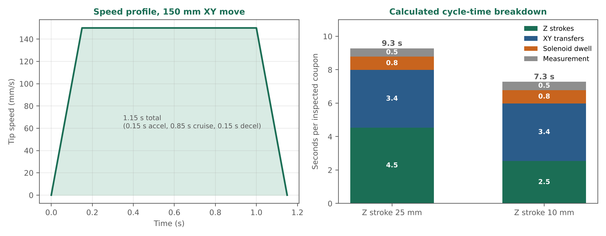
Figure 9. Left: speed profile for a 150 mm XY move. Right: cycle-time breakdown of one inspected coupon.
The Z-axis is the bottleneck. The eight Z strokes take 4.5 s of the 9.3 s inspection cycle (about 49%) with a 25 mm stroke. Cutting the stroke to 10 mm shortens the cycle by about 22% with no other change. The Z-axis also needs the highest pulse rate in the system (about 6000 pulses/s), while the shoulder needs only a few hundred.

12.4 Accuracy results
Resolution is the smallest movement the controller can command and sets a floor on accuracy. At the tool, the joint errors add: a shoulder error Δθ1 moves the tip by about R·Δθ1, where R is the distance from the base to the tip, and an elbow error Δθ2 moves it by about L2·Δθ2.
Metric | Calculation | Result
Joint resolution, direct drive | 1.8° ÷ 16 | 0.1125° per microstep
Tip resolution at 280 mm reach | (280 + 120) × 0.001963 | ≈ 0.79 mm (worst case)
Tip resolution at 150 mm reach | (150 + 120) × 0.001963 | ≈ 0.53 mm (worst case)
Z resolution | 8 mm ÷ 800 pulses | 10 µm per step
Motor step accuracy at 280 mm | ±0.09° = 0.00157 rad; 400 × 0.00157 | ≈ ±0.63 mm (worst case)

Microstepping resolution is not the same as accuracy. The achievable accuracy is set by the motor step accuracy and by mechanical errors such as belt slack, joint play and link flex. A reduction stage on the joints improves both resolution and motor-limited accuracy in proportion to its ratio, at the cost of joint speed.

12.5 Check-station performance
The check station is judged by how well it separates the three coupon classes and by how much the reading varies when the same coupon is measured again. The design aims are:
- Reading repeatability: the standard deviation of 30 repeated readings of one reference coupon stays well inside the guard band between classes.
- Class separation: the readings of the bare, insulating and antistatic coupons form three separate groups with no overlap.
- Overall efficiency: at least 99 of 100 coupons are picked, measured and sorted correctly, and no bad coupon is accepted.

12.6 Validation plan and results sheet
The tests below confirm the figures. Position repeatability and accuracy follow the approach of ISO 9283, reporting the mean error plus three standard deviations.
Test | Method | Target | Record
XY repeatability | Go to one point 30 times, alternating approach direction; measure with a dial indicator or a camera on a millimetre grid | ≤ ±0.5 mm | Mean + 3σ
XY accuracy | Command a 5 × 5 grid at 25 mm spacing; compare commanded and measured positions | ≤ ±1.0 mm | Max error
Z repeatability | Lower to the same height 30 times and read a dial indicator | ≤ ±0.2 mm | Mean + 3σ
Cycle time | Time 20 consecutive inspection cycles and divide by 20 | ≤ 8 s | Mean time
Pick success rate | Run 100 cycles and count successful picks | ≥ 99% | Count
Home drift | After 100 cycles return to the home marker and measure the offset | ≤ 1 mm | Offset
Reading repeatability | Measure one reference coupon of each class 30 times | Clear guard band | Mean, σ
Classification accuracy | Run 100 mixed coupons (bare, insulating, antistatic) through the station | ≥ 99% correct, 0 false accepts | Confusion matrix

13. Future Scope
- Vision integration. A fixed camera to locate parts and coupons, supply target coordinates and verify each placement.
- Collaborative SCARAs. Two or more arms sharing a work area, for example one loading coupons and one sorting them.
- Miniaturisation. A smaller, lighter arm and a compact station for a smaller footprint.
- Check-station upgrades. A concentric-ring electrode for a surface-resistance reading in line with IEC 61340-2-3, a temperature and humidity log, and a live display of the results.
- Motion upgrades. A shorter Z stroke, overlapped Z and XY moves, a higher supply voltage and a joint reduction stage, plus joint encoders and limit switches to detect missed steps.

14. Conclusion
This SCARA robot is a compact and inexpensive pick-and-place arm. Its two vertical-axis rotary joints, lead-screw Z-axis, stepper actuation and electromagnet gripper keep the design simple, and its kinematics have a closed-form solution that an Arduino Mega can run. The prototype reaches 150 mm/s in the horizontal plane and 60 mm/s vertically, which gives a calculated inspection cycle of about 7 to 9 seconds per coupon.
The antistatic coating check station turns the robot into a small quality-control cell. A resistor divider and a spring probe measure the coating, a simple window decides pass or reject, and the robot sorts the coupons automatically. Project planning, an inspection and test plan, and a data-analysis method give the work the structure of a plant process: targets are defined, results are recorded and limits are set from data. The system is designed to meet a 99% efficiency target, and the validation plan in Section 12.6 is the way to confirm it.

15. Sources and References
- Craig, J. J., Introduction to Robotics: Mechanics and Control, Pearson. Planar two-link kinematics and the law-of-cosines solution.
- Spong, M. W., Hutchinson, S. and Vidyasagar, M., Robot Modeling and Control, Wiley. Kinematics, workspace and singularities.
- ISO 9283, Manipulating industrial robots: performance criteria and related test methods.
- IEC 61340-5-1, Protection of electronic devices from electrostatic phenomena: general requirements.
- IEC 61340-2-3, Methods of test for determining the resistance and resistivity of solid planar materials used to avoid electrostatic charge accumulation.
- Project assembly drawing SRP-001, Rev 01, and the project circuit diagram.

